

**Faculty of Engineering and Technology**

**Electrical and Computer Engineering**

**Department**

**Communication Laboratory**

**ENEE4113**

**Prelab Exp 2 DSB-SC and SSB-SC**

**Prepared by:**

Arwa Doha 1190324

**Instructor:** Dr.Ashraf Rimawi

**Assistant:** Eng.Mohammed Battat

**Section:** 6

**Date:** October 4, 2023

Table of Contents

Double Sideband Suppressed Carrier (DSB-SC) Modulation and Demodulation 3

DSB-SC Modulation Simulink : 3

Message signal : 3

Message signal in time domain 4

Message signal in frequancy domain: 4

Carrier Signal 4

Carrier signal in time domain: 5

Carrier signal in frequancy domain 5

Modulated signal s(t): 5

Modulated signal in Time Domain : 6

Modulated signal in Frequency Domain : 6

Parameters: 7

Demodulation: 7

Demodulation in frequency domain : 8

Demodulation in time domain 8

Parameters: 8

Single SideBand Suppressed Carrier (SSB-SC) Modulation and Demodulation 9

SSB-SC Modulation 🡪 Method1: lower Side 9

Time domain in SSB-SC Modulation method1: 9

Frequency domain in SSB-SC Modulation method1: 10

Parameters 10

SSB-SC Demodulation lower sideband 11

Time domain of SSB-SC DeModulation lower sideband: 11

Frequancy domain of SSB-SC DeModulation lower sideband 11

Parameters: 12

SSB-SC Modulation🡪 Method2: lower Side 12

SSB-SC Modulation in Time Domain : 13

SSB-SC Modulation in frequency Domain : 13

Parameters 13

SSB-SC Demodulation Method2 14

SSB-SC Demodulation in Time Domain : 14

SSB-SC Demodulation in Freq Domain : 14

**Software Prelab (Simulink Matlab)**

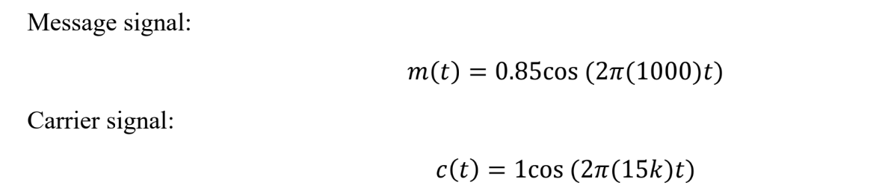

Figure Information of Signals

# Double Sideband Suppressed Carrier (DSB-SC) Modulation and Demodulation

## DSB-SC Modulation Simulink :

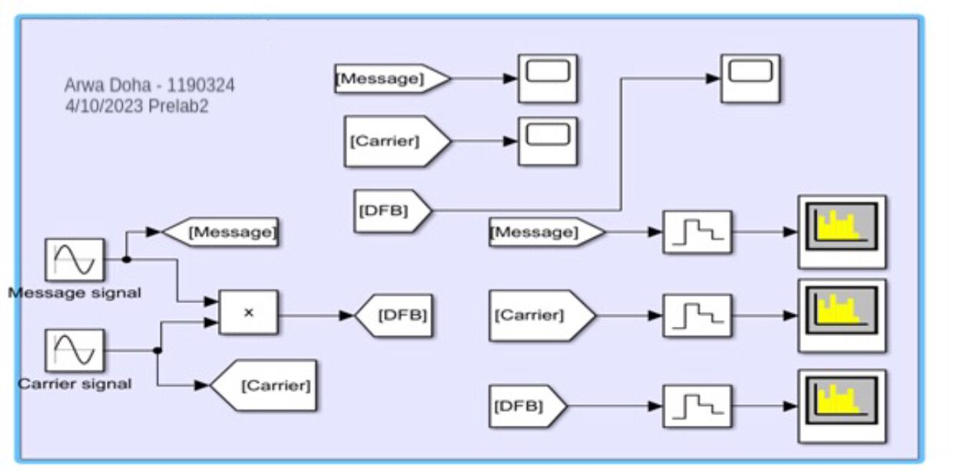

Figure DSB-SC Modulation Simulink

## 

## Message signal :

The message signal's amplitude stands at 0.85, a critical factor in determining the extent of modulation. It is imperative to maintain a modulation depth below 1 to prevent any potential distortion from occurring.

### Message signal in time domain

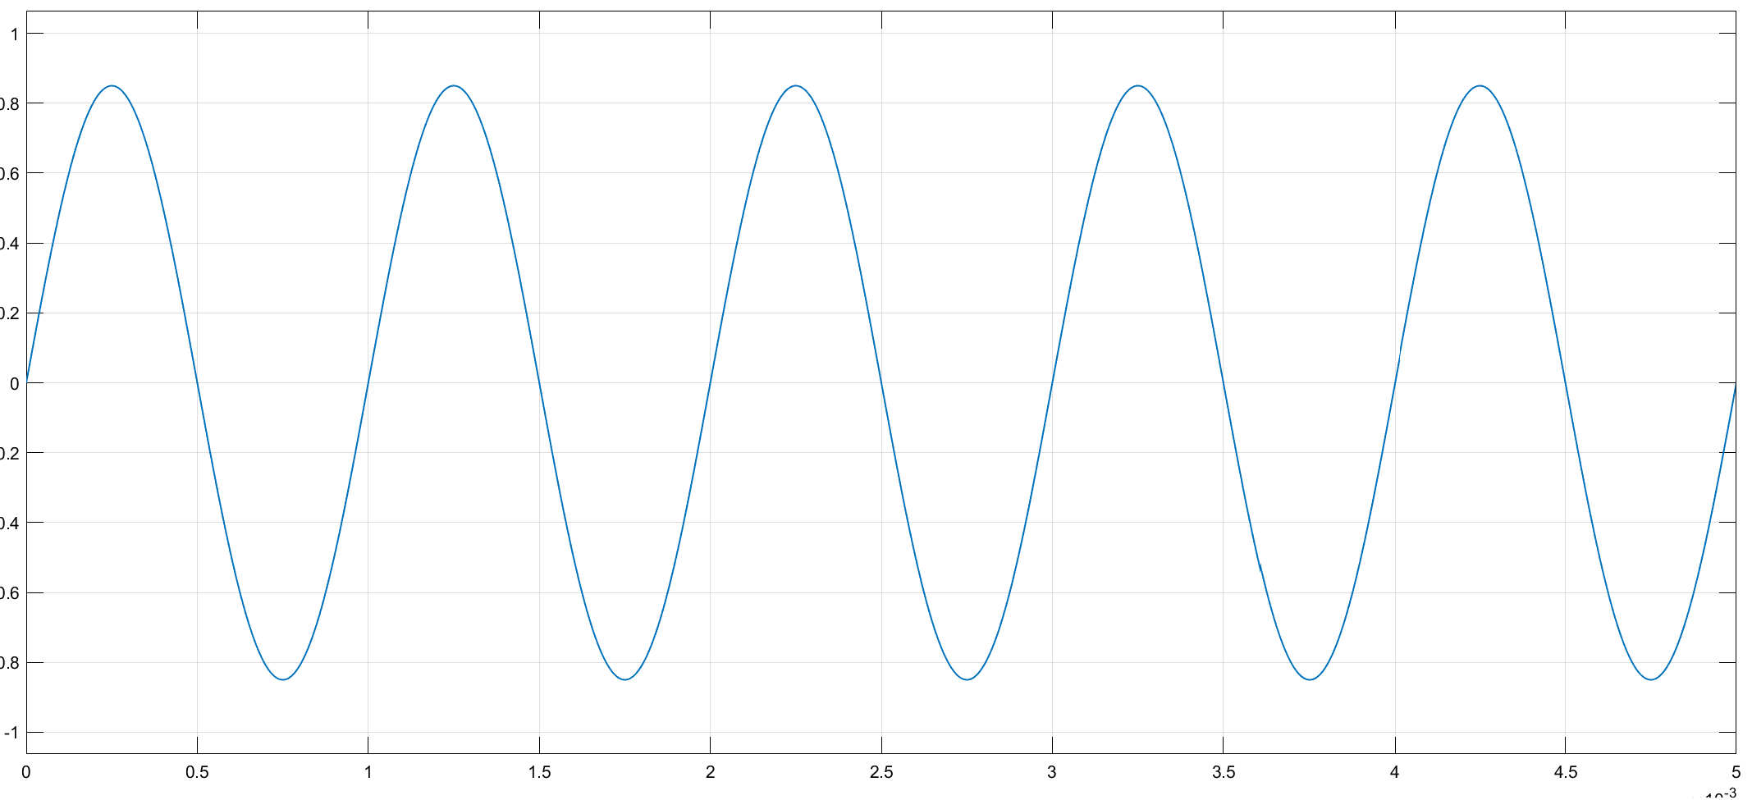

Figure Message signal (DSB-SC) in time domain

### Message signal in frequancy domain:

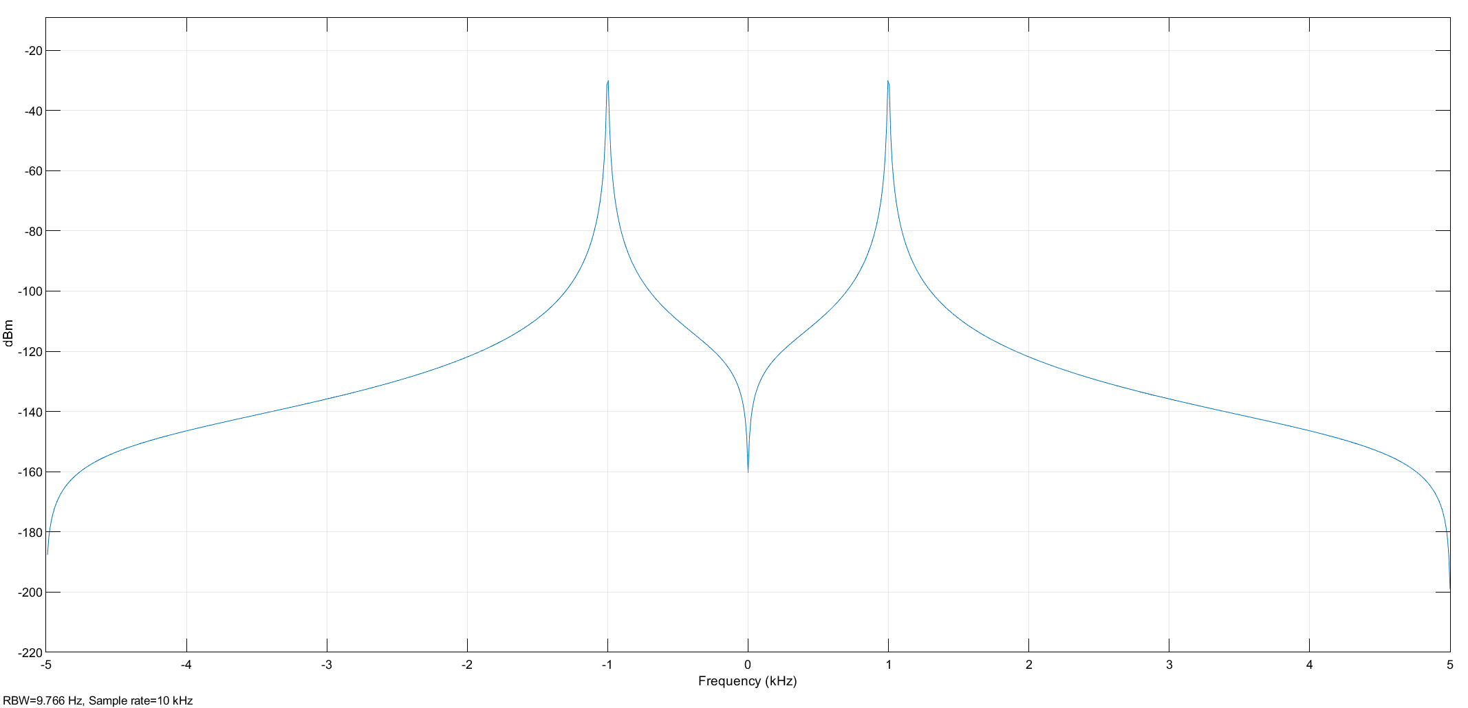

Figure Message signal (DSB-SC) in freq domain

## Carrier Signal

The carrier frequency, set at 15 kHz, is notably higher than the frequency of the message signal, which is 1 kHz. This frequency difference serves the purpose of elevating the message signal to a more efficient transmission and modulation range.

### Carrier signal in time domain:

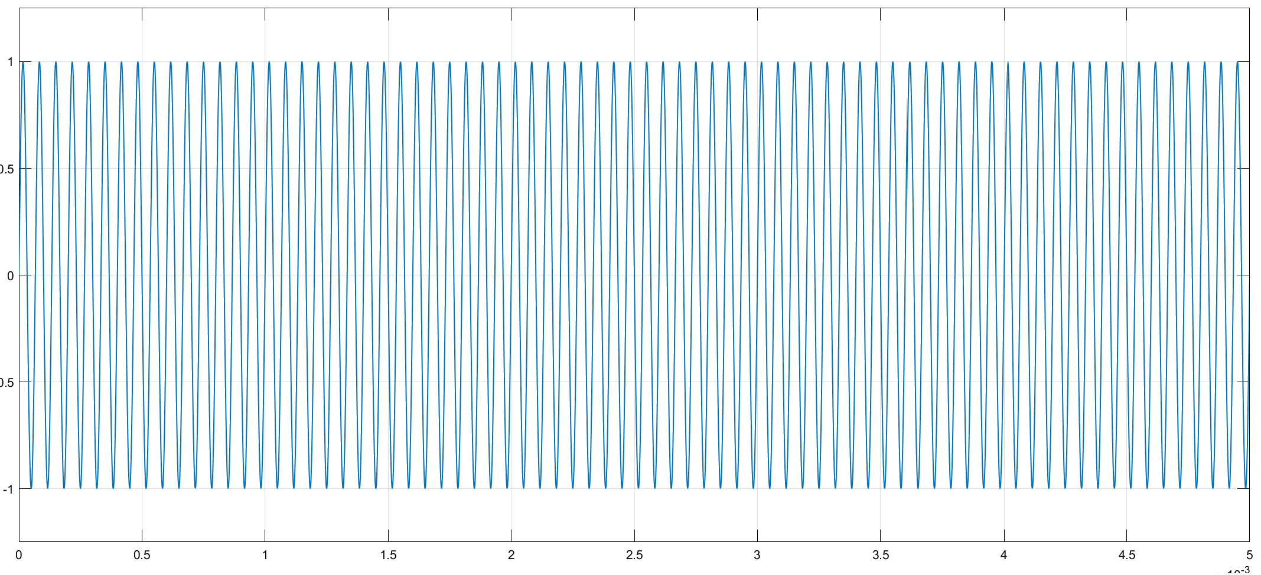

Figure Carrier signal (DSB-SC) in time domain

Carrier signal in frequancy domain: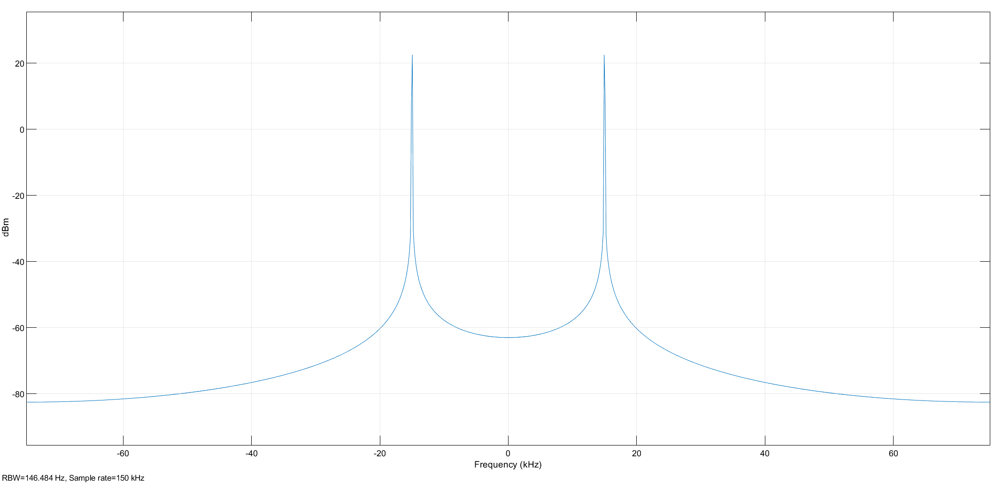

Figure Carrier signal (DSB-SC) in freq domain

## Modulated signal s(t):

The carrier signal undergoes modulation by the message signal through a multiplication process. Consequently, the outcome is a Double Sideband Suppressed Carrier (DSB-SC) modulated signal, encompassing both upper and lower sidebands, while the carrier signal itself is eliminated or suppressed.

### Modulated signal in Time Domain :

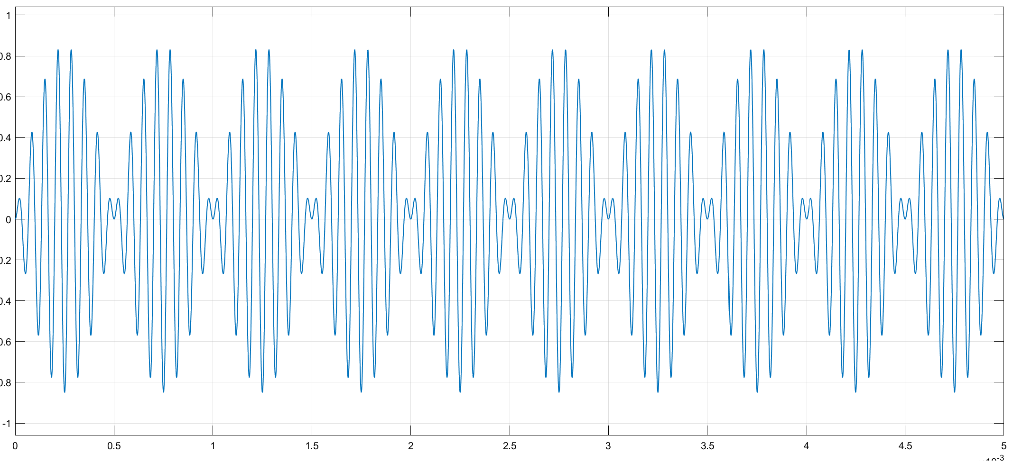

Figure S(t) in time domain in DSB

### Modulated signal in Frequency Domain :

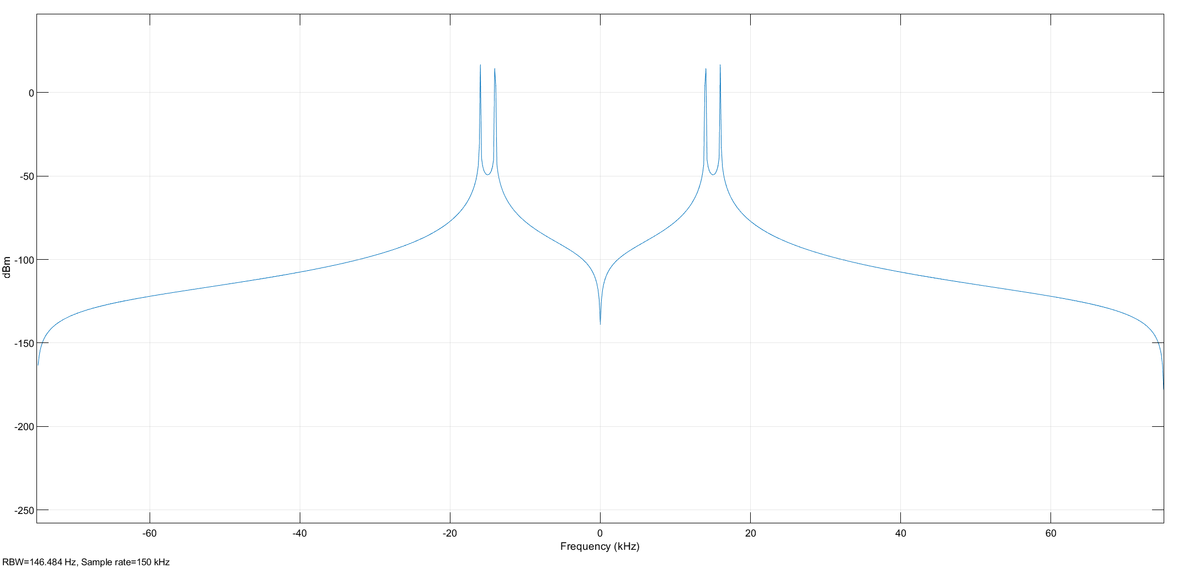

Figure S(t) in freq domain in DSB

### Parameters:

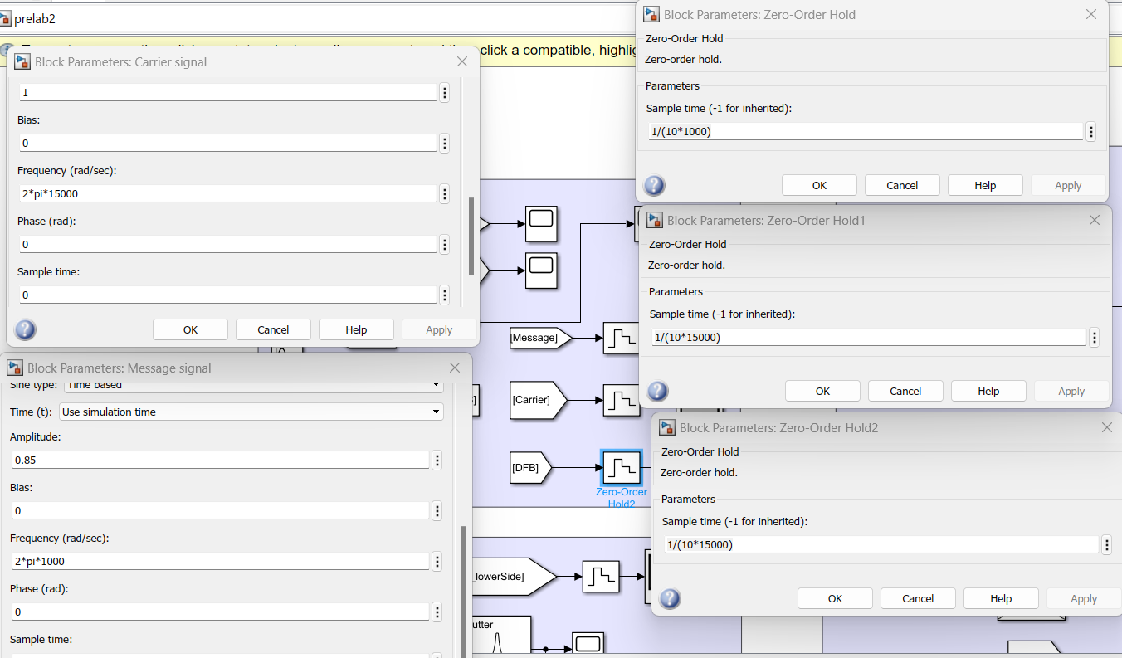

Figure parameters used in DSB-SC Modulation Simulink

## Demodulation:

Demodulating a DSB-SC signal entails the extraction of the original message signal by removing the carrier component from the modulated signal. 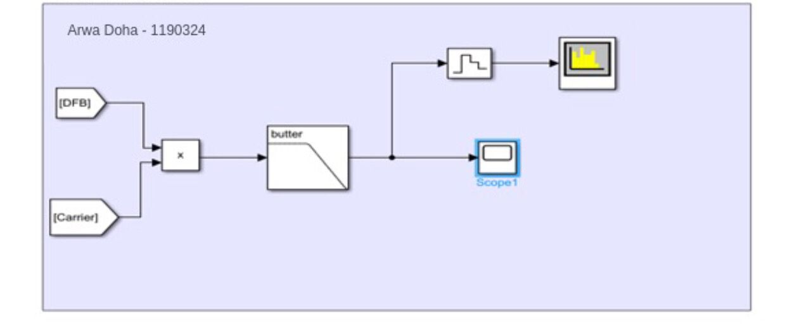

Figure DSB-SC Demodulation Simulink

### Demodulation in frequency domain :

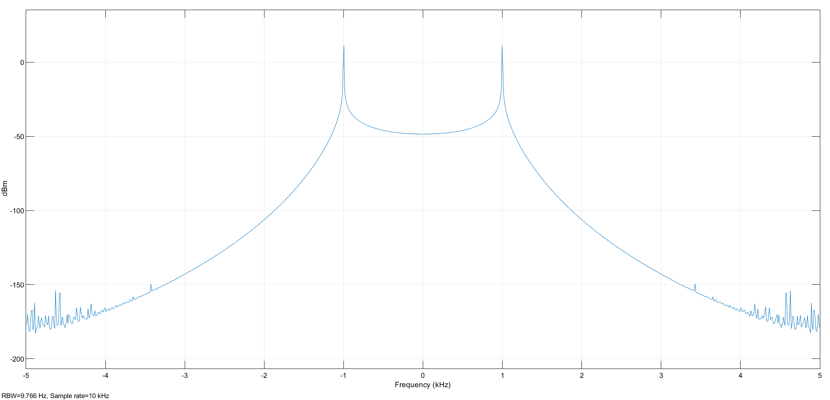

Figure DSB-SC Demodulation frequency domain

Demodulation in time domain 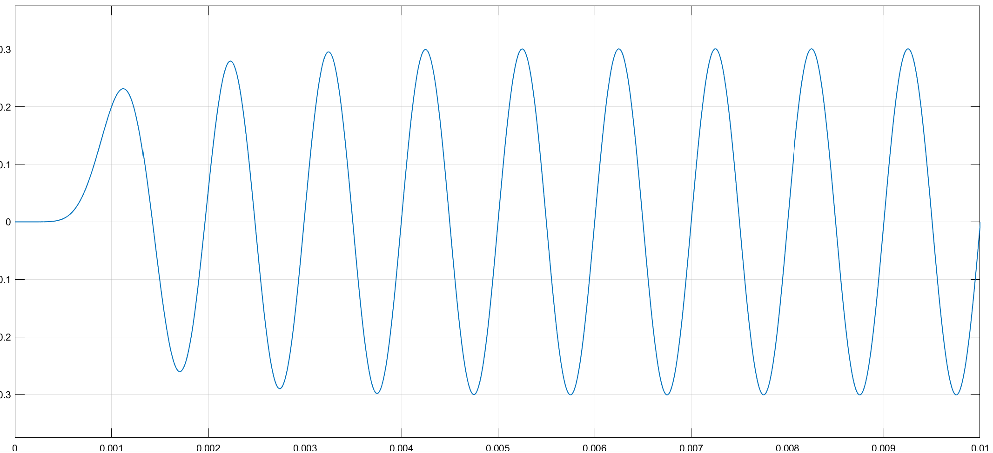

Figure DSB-SC Demodulation in time domain

During the demodulation process of DSB-SC, the carrier is effectively removed, thereby revealing the original message signal. This phenomenon is evident in both the time domain, as illustrated in Figure 12, and the frequency domain, as depicted in Figure 11 representations.

### Parameters:

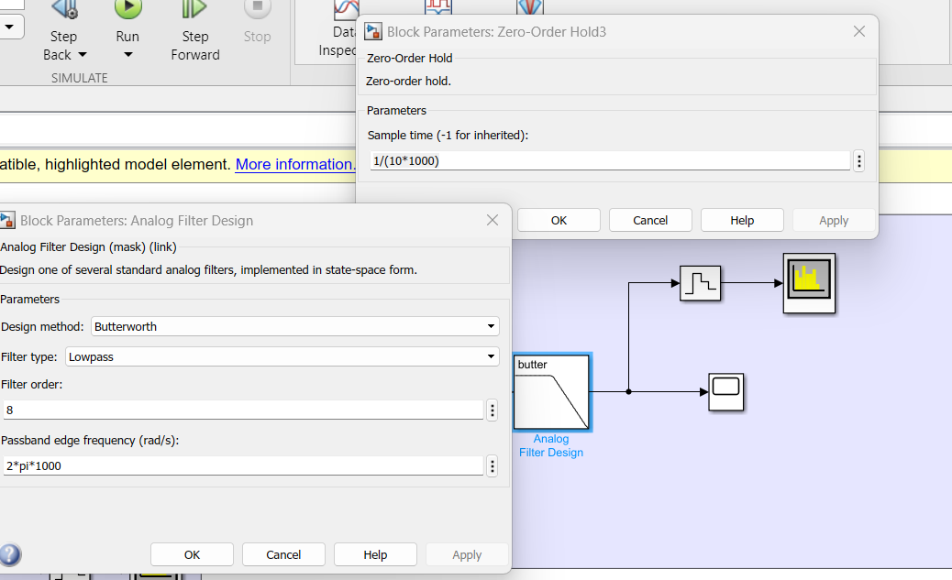

Figure parameters used in DSB-SC Demodulation Simulink

# Single SideBand Suppressed Carrier (SSB-SC) Modulation and Demodulation

## SSB-SC Modulation 🡪 Method1: lower Side

The modulation process involves the message signal modulating the carrier signal, akin to DSB-SC modulation. However, in the lower sideband scenario, both the upper sideband and the carrier are suppressed, resulting in only the lower sideband being present in the modulated signal.

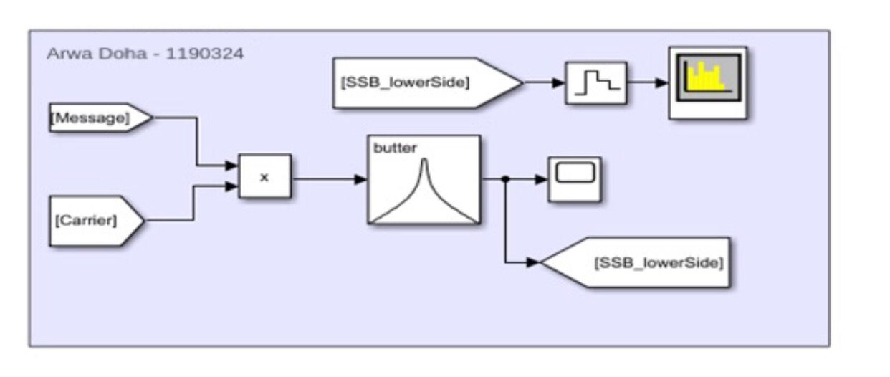

Figure SSB-SC Modulation lower Side lower Side

### Time domain in SSB-SC Modulation method1:

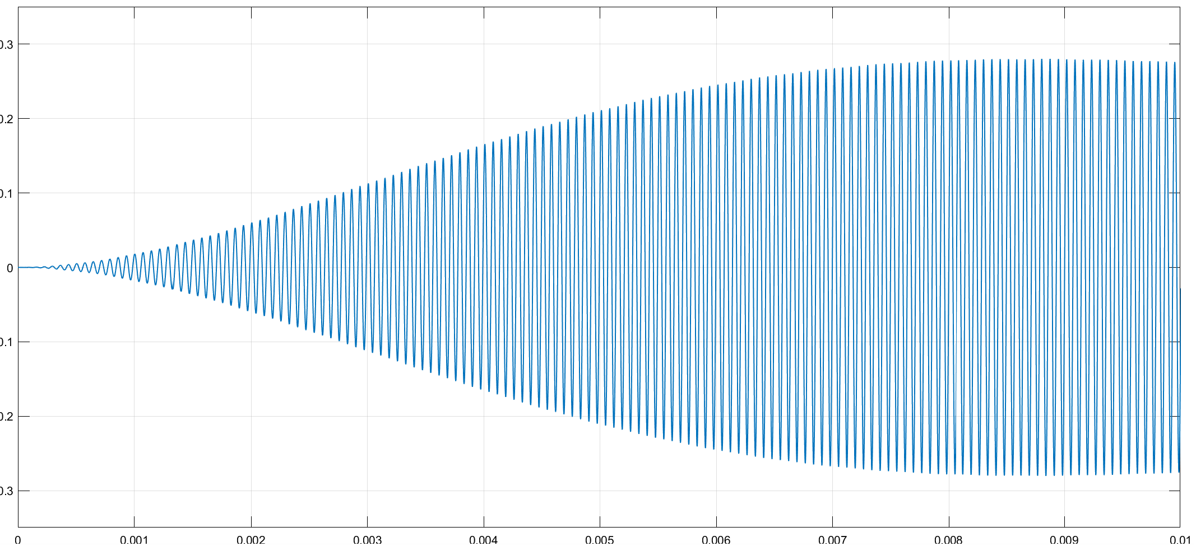

Figure Time domain in SSB-SC Modulation method 1

### Frequency domain in SSB-SC Modulation method1:

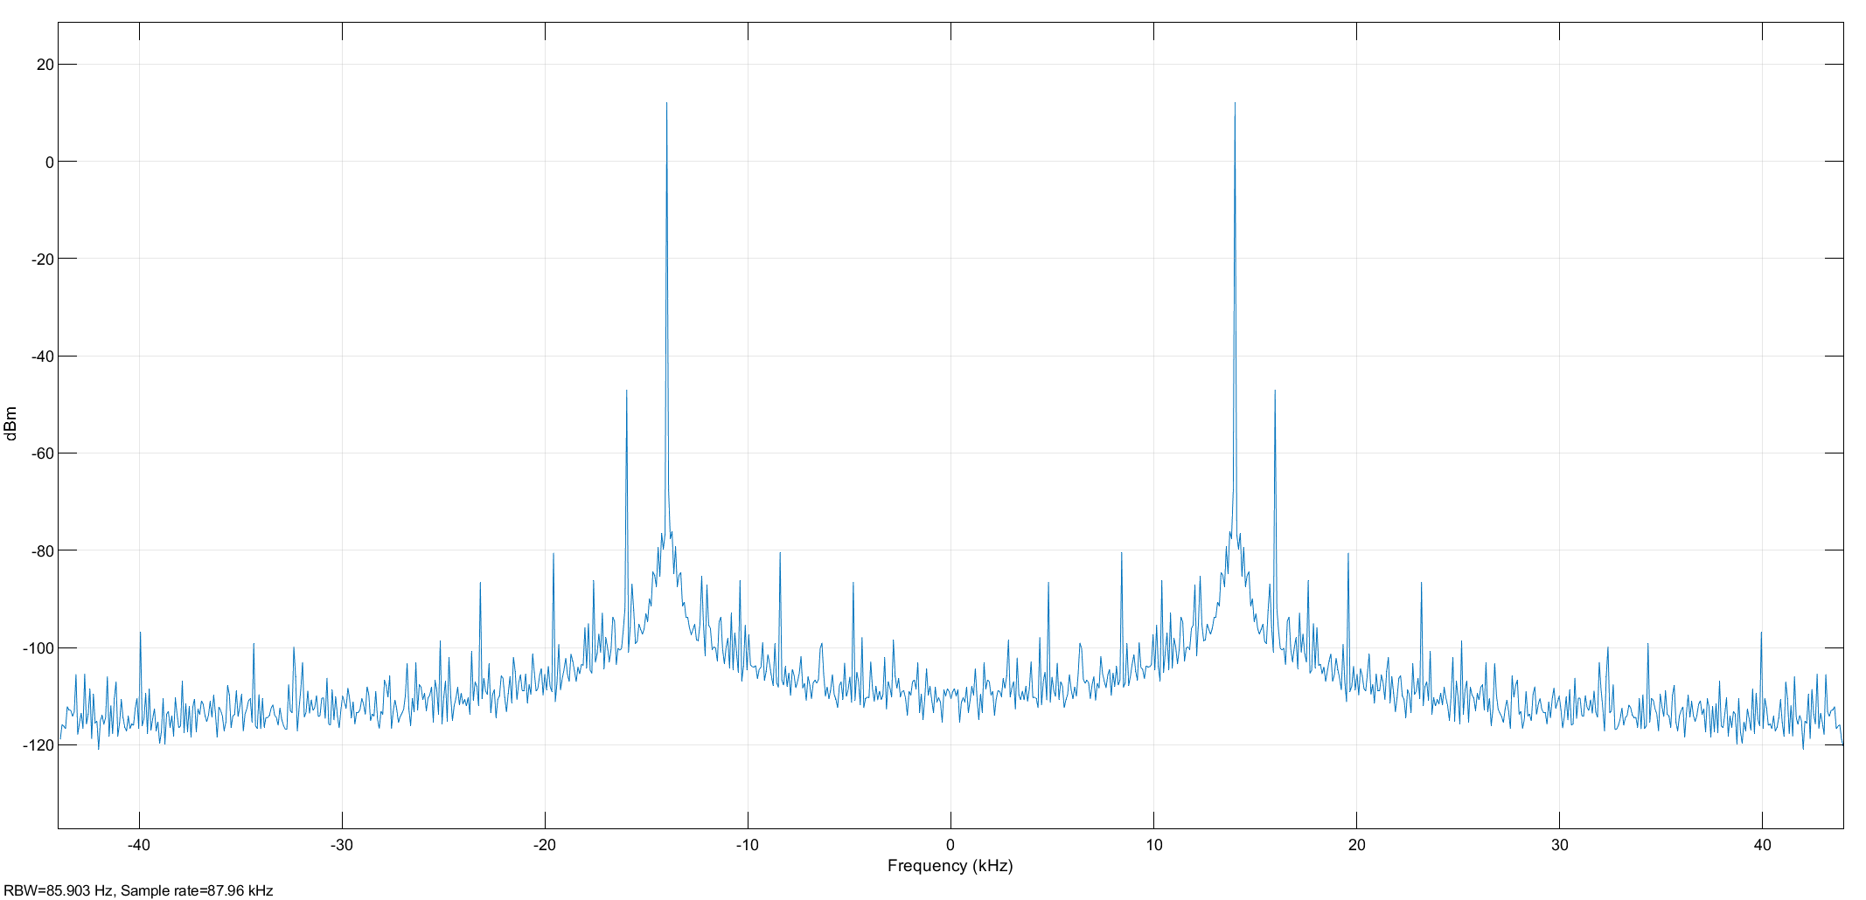

Figure Frequency domain in Single suppressed carrier Modulation method 1

In the case of single suppressed carrier modulation (lower sideband), the message signal modulates the carrier signal in a manner similar to DSB-SC modulation. However, in this specific scenario, both the upper sideband and the carrier are suppressed, leading to the transmission of only the lower sideband.

This modulation process is visually depicted in Figure 14. The time domain representation is observable in Figure 15, whereas Figure 16 illustrates the frequency domain representation of this modulation technique.

Parameters 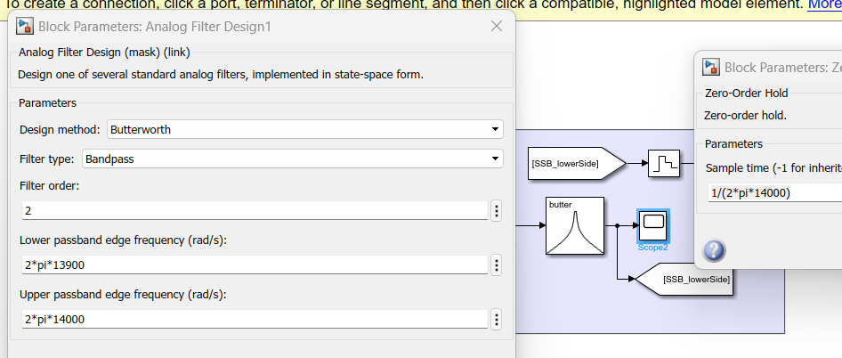

Figure Parameters used in SSB-SC Modulation lower Side simulink

## SSB-SC Demodulation lower sideband

Demodulating the lower sideband of (SSB-SC) signal involves the reconstruction of the original message signal from the received signal. This process allows for the extraction of the original information carried by the lower sideband.

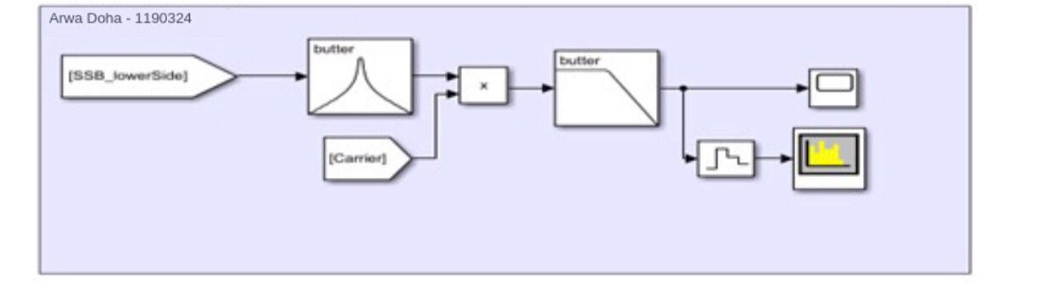

Figure SSB-SC DeModulation lower Side lower Side simulink

### Time domain of SSB-SC DeModulation lower sideband:

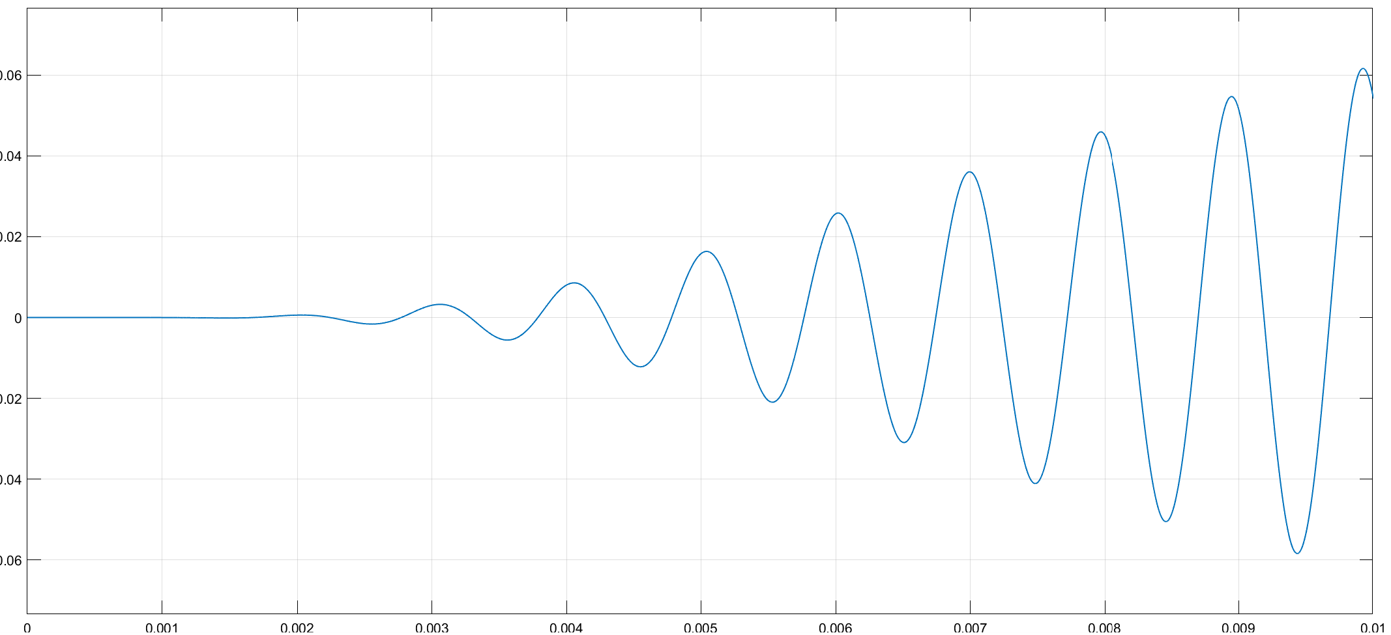

Figure Time domain of SSB-SC DeModulation lower sideband

Frequancy domain of SSB-SC DeModulation lower sideband 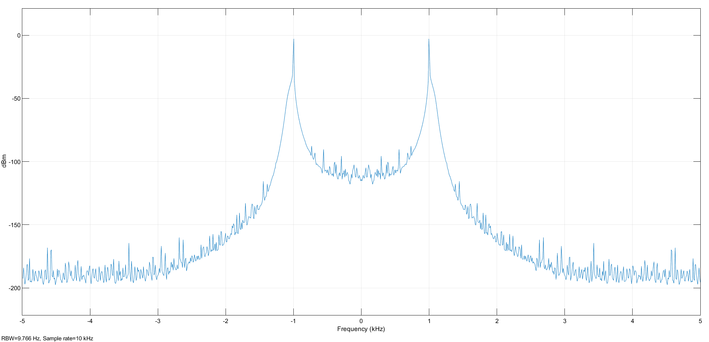

Figure SSB-SC Demodulation LS in freq domain

During the demodulation process of the Single Suppressed Carrier Modulation Method 1 (lower side), the primary objective is to reconstruct the original message signal from the received signal. This demodulation process aims to recover the original information contained within the lower sideband.

The demodulation process is visually represented in Figure 18. The time domain depiction of the demodulation can be observed in Figure 19, and Figure 20 displays the frequency domain representation of the demodulated signal for Method 1 of single suppressed carrier modulation (lower side).

### Parameters:

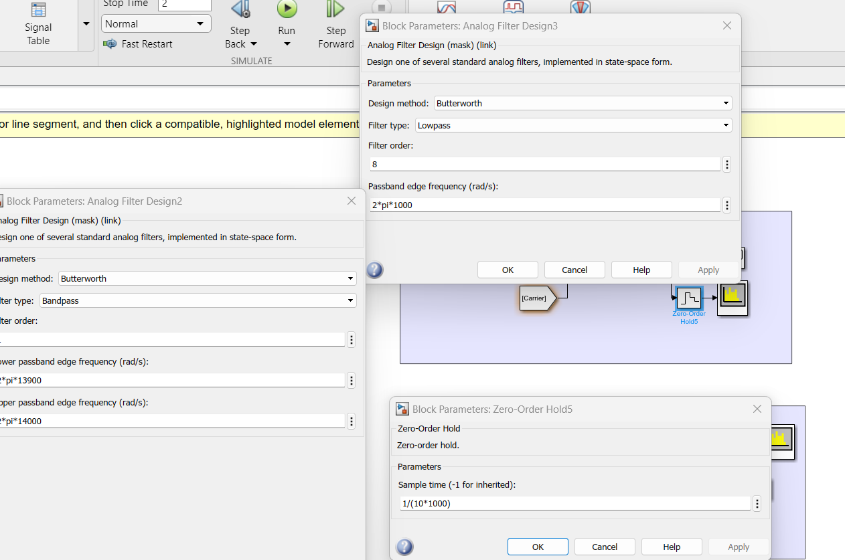

Figure Parameters used in SSB-SC DeModulation LS simulink

## SSB-SC Modulation🡪 Method2: lower Side

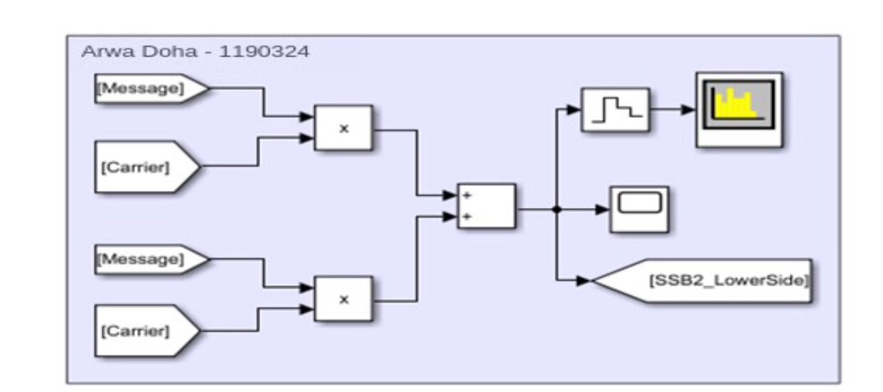

Figure SSB-SC Modulation Method2(lower Side)

### SSB-SC Modulation in Time Domain :

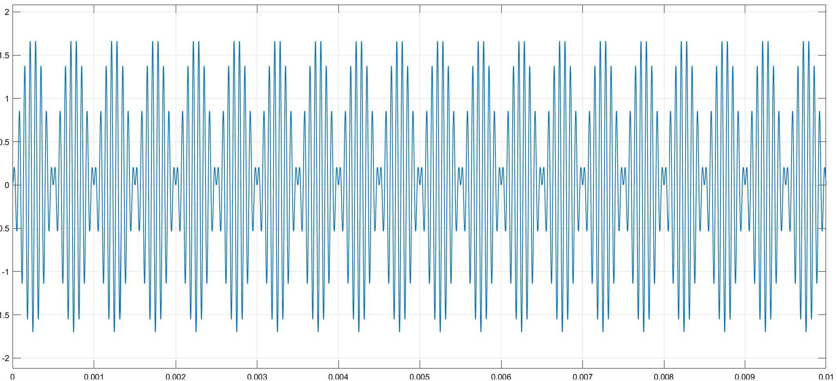

Figure SSB-SC Modulation in time domin

### SSB-SC Modulation in frequency Domain :

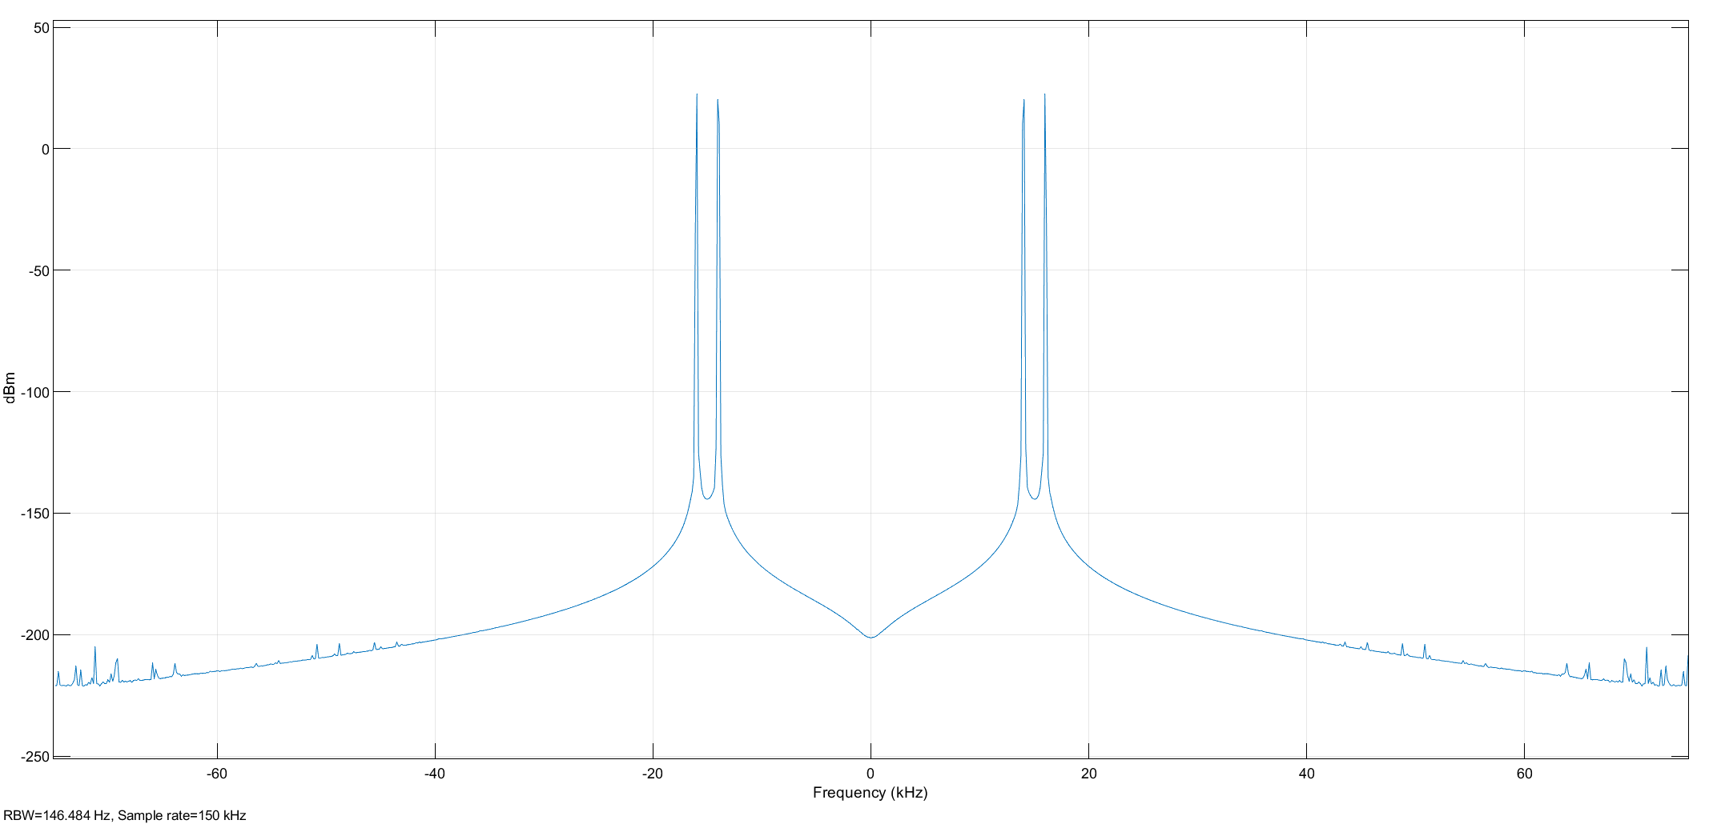

Figure SSB-SC Modulation in frequency Domain

### Parameters

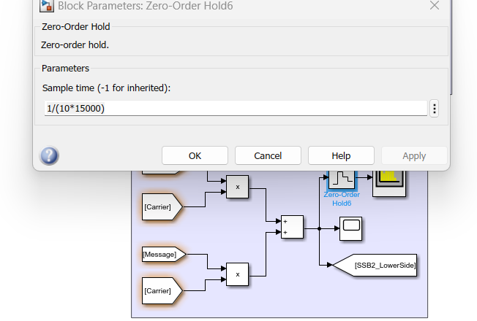

Figure Parameters used in SSB-SC Modulation simulink

## SSB-SC Demodulation Method2

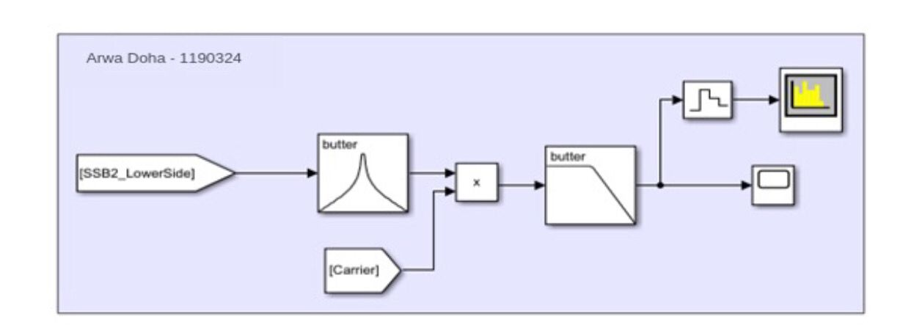

Figure SSB-SC Demodulation(Method2) simulink

### SSB-SC Demodulation in Time Domain :

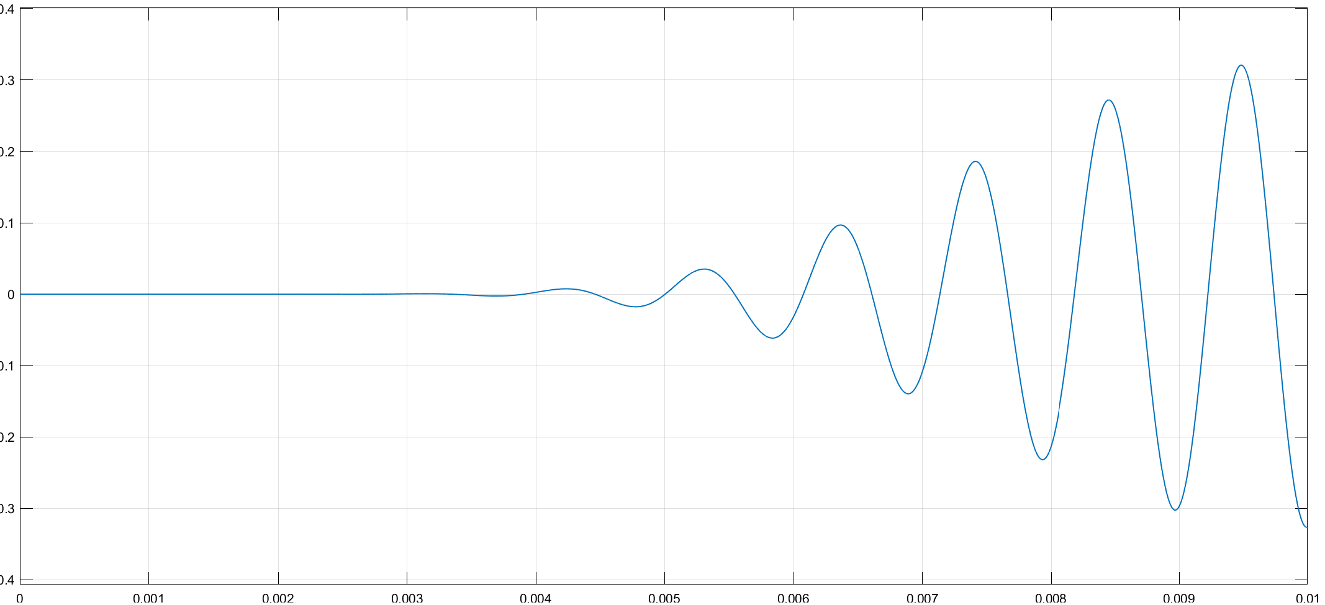

Figure Ttime domain of SSB-SC Demodulation

### SSB-SC Demodulation in Freq Domain :

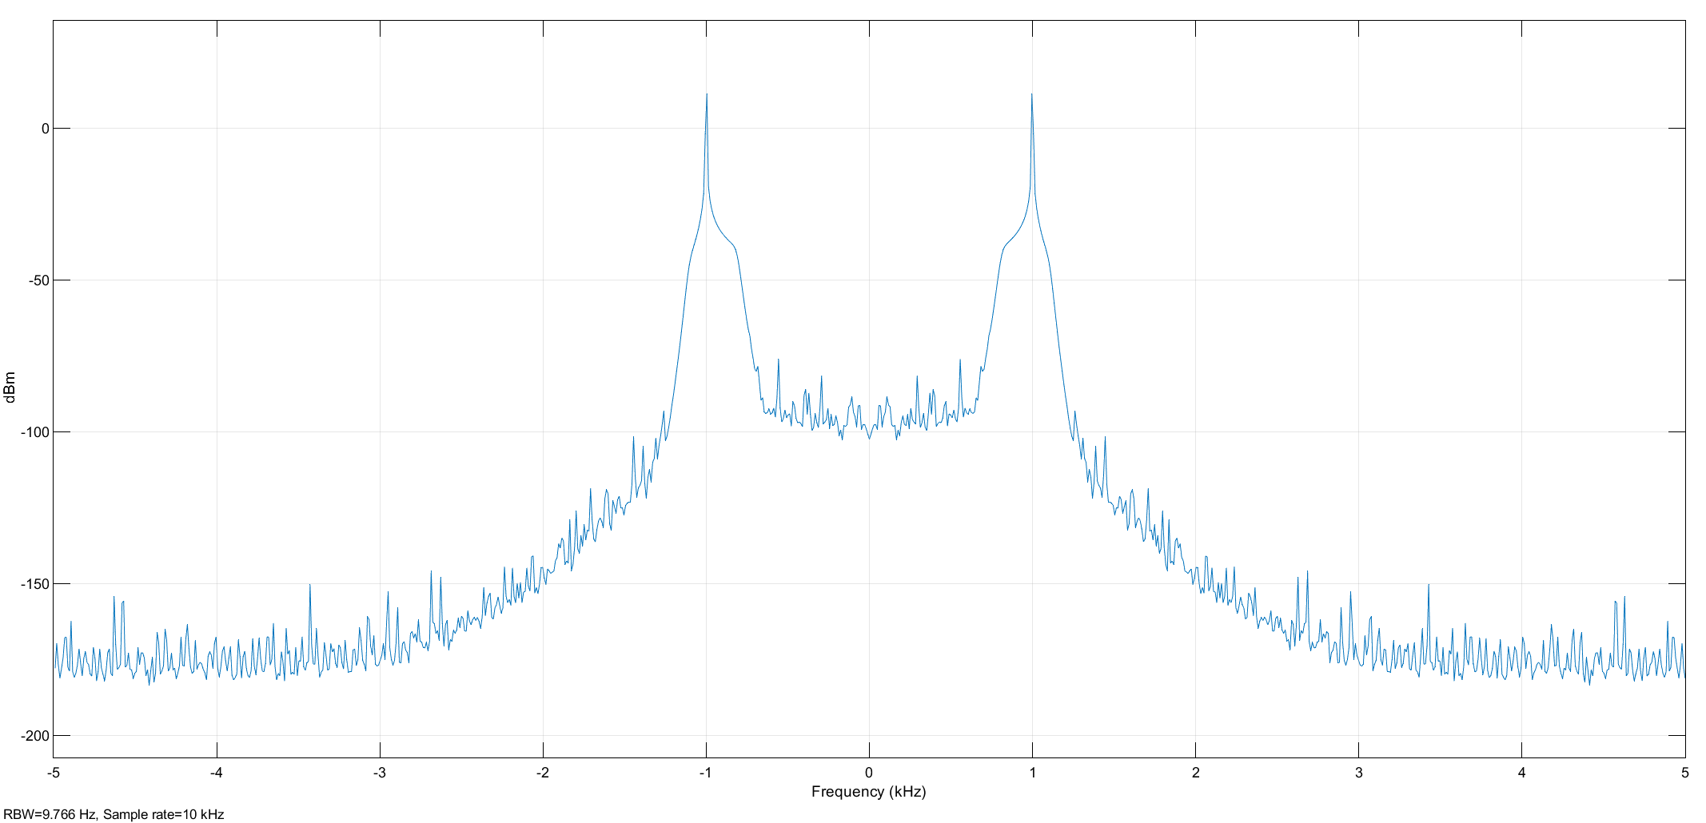

Figure Frequency Domain of SSB-SC Demodulation

Parameters

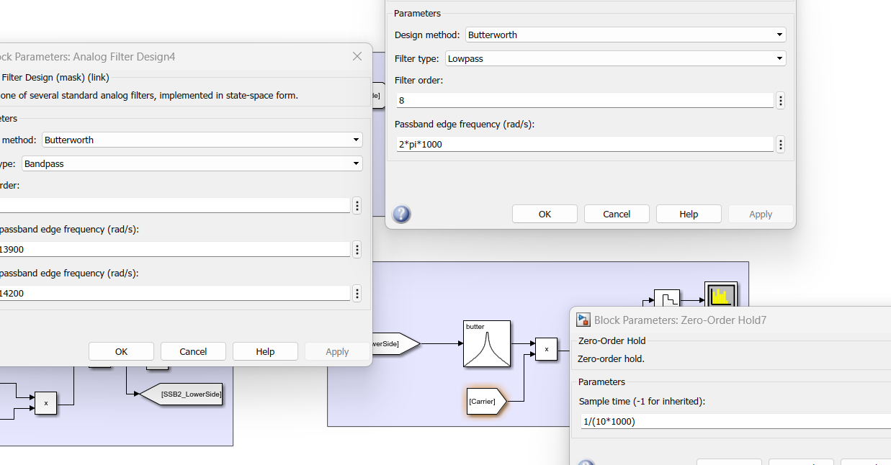

Figure Parameters used in SSB-SC Demodulation

In the context of single suppressed carrier modulation Method 2 (lower side), the modulation process involves the message signal modulating the carrier signal, which is similar to the DSB-SC modulation.

This modulation technique is depicted in Figure 22. The time domain representation of this modulation process can be observed in Figure 23, and Figure 24 displays the frequency domain representation of the modulated signal.

In the demodulation process of the single suppressed carrier using Method 2, the objective is to extract the original message signal from the received signal. This process allows for the recovery of the original information carried by the signal.

The demodulation process is visually illustrated in Figure 26. To further analyze the demodulation, you can refer to Figure 27 for the time domain response, and Figure 28 offers a depiction of the frequency domain characteristics of the demodulated signal.